SENDING ORDER WRITE-UPS VIA E-MAIL

THERE IS AN ADDIITONAL OPTION FOR SENDING ORDER WRITE-UPS TO THE FACTORY.

Do write-ups the same as before, hitting the Save and Continue button at the bottom of pages 1, 2, and 3.

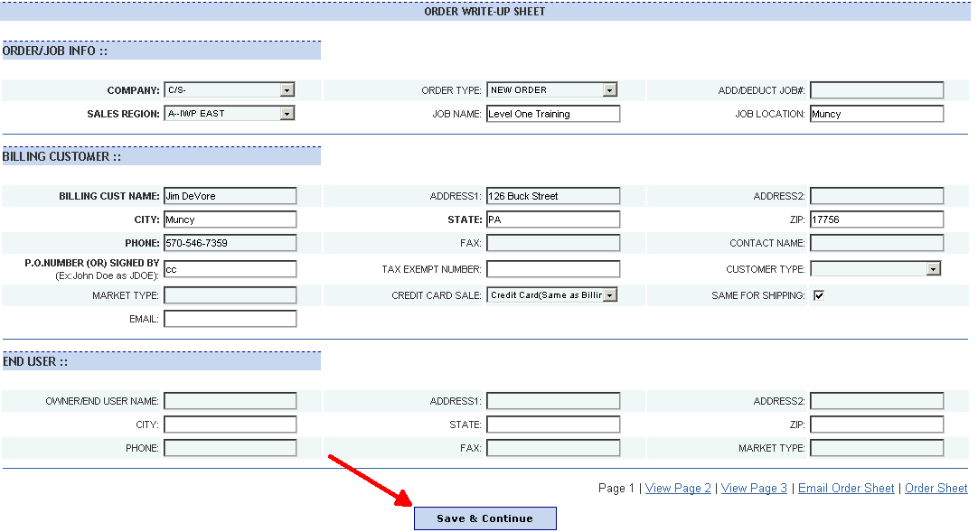
This ensures all of your data is written to the table that stores the information. Hitting this on page three takes you directly to the on screen order write-up.

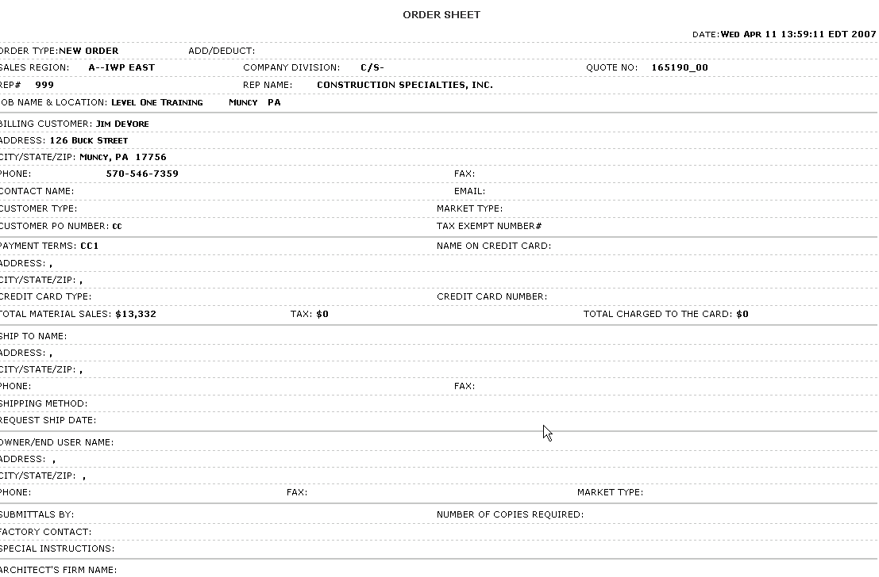
Review this for completeness. When satisfied, click your right mouse button to get the tool bar, and click on Back.

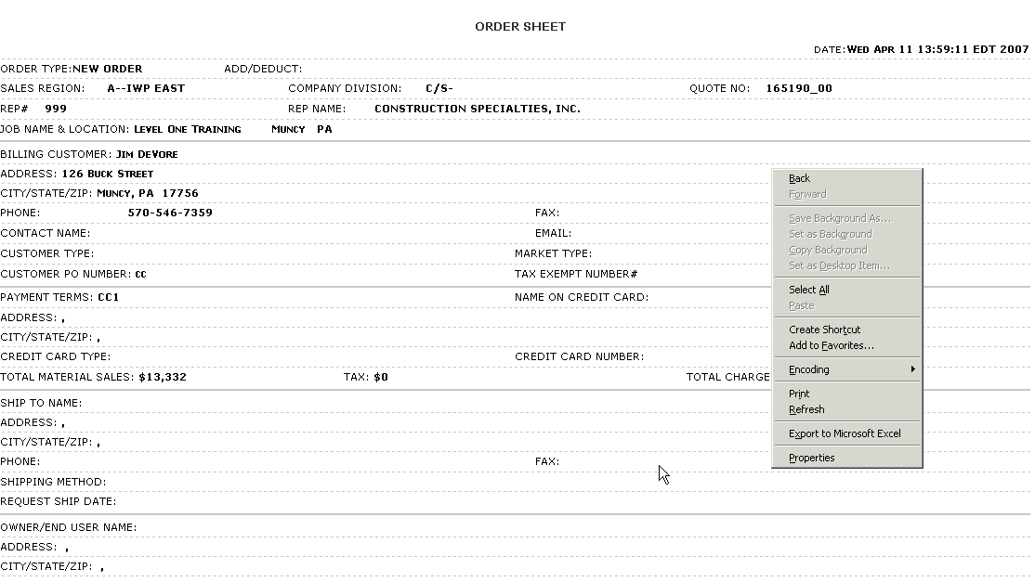
This take you back to page 3, where you can select “email order sheet”.

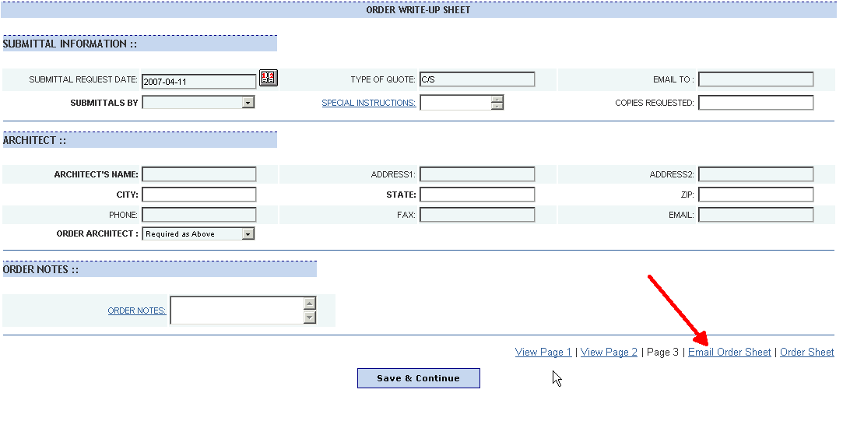
Once you select this, you will have a page that allows you to send e-mail by typing the address in, as well as notes:

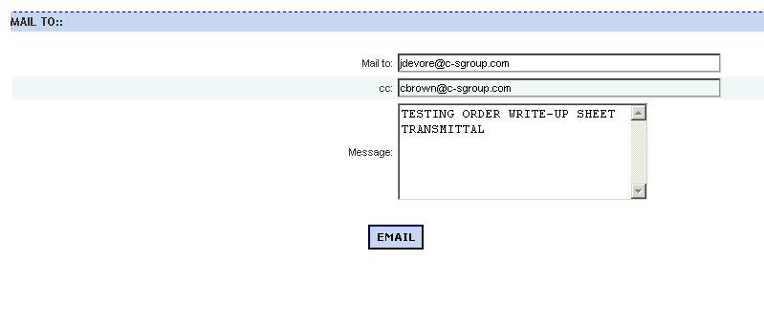
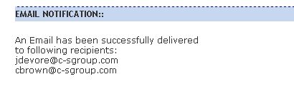
Fill it in as required, hit the e-mail button.

This screen will appear – simply close it:

The person you send it to will receive an e-mail that looks like this:

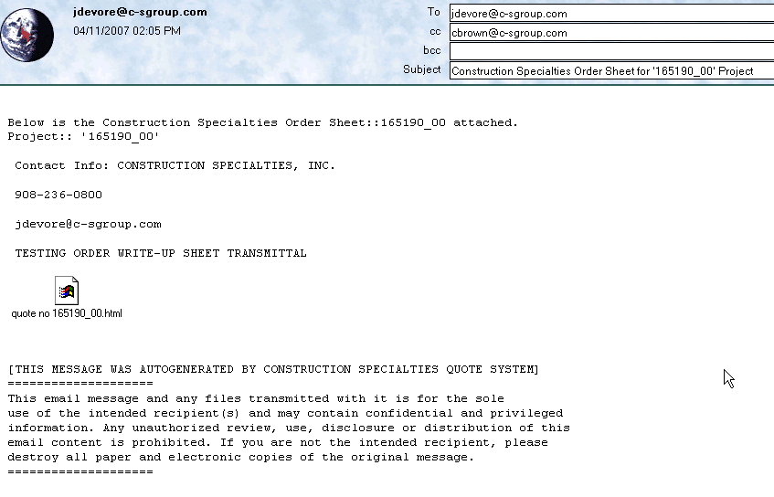
They can open the attachment and print, save, or file.

